QUADRATURE PHASE SHIFT KEYING(QPSK)

* Quadrature Phase Shift Keying (QPSK) is a form of Phase Shift Keying in which two bits are modulated at once.
* Since two bits are modulated at once, we need four phases (i.e) 4 possible combinations with 2 bits , which are: 00, 01,10,11.
* In QPSK, we have 4 phases and therefore we divide the 360° phase into 4 phases (i.e) 360/4 =90°.
* So here we have separation of 90° in 4 phases.
* In QPSK, we use 45°,(45+90=135°),(135+90=225°),(225+90=315°)
* QPSK allows the signal to carry twice as much information as ordinary PSK using the same bandwidth. QPSK is used for satellite transmission of MPEG2 video, cable modems, video conferencing, etc..

MULTIPLEXING

* A fundamental mechanism in communication system and networks
* Enables multiple users to share a medium
* Multiplexing is a method that can be used to combine multiple analog or digital signals into one signal over a shared medium.
* **The concept behind it is very simple: Proper Resource Sharing and its Utilization**
* For wireless communication, multiplexing can be carried out in four dimensions: space, time, frequency and code

FREQUENCY DIVISION MULTIPLEXING

* In this, a number of signals are transmitted at the same time, and each source transfers its signals in the allotted frequency range.
* There is a suitable frequency gap between the 2 adjacent signals to avoid over- lapping. These strips of unused frequencies are called guard bands.
* The frequency spectrum is divided into several logical channels, in which every user feels that they possess a particular bandwidth.

**For example:** In cable TV, you can see that only one cable is reached to the customer's locality, but the service provider can send multiple television channels or signals simultaneously over that cable to all customers without any interference. The customers have to tune to the appropriate frequency (channel) to access the required signal.

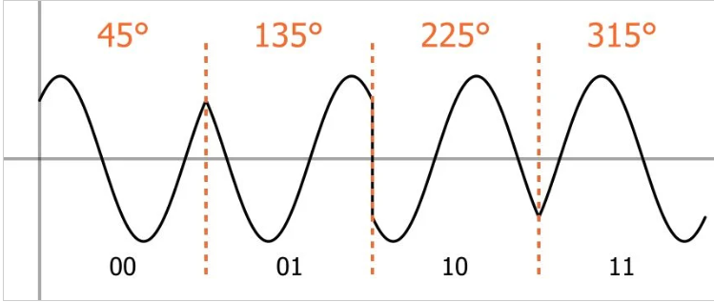

QUADRATURE PHASE SHIFT KEYING

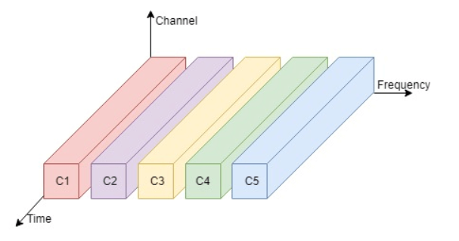

FREQUENCY DIVISION MULTIPLEXING